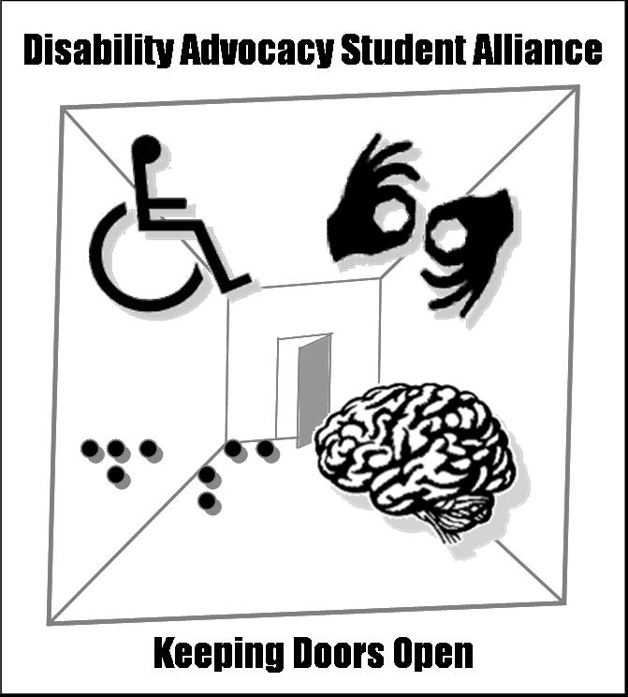

Disability Advocacy Student Alliance’s

2007 Disability Awareness Program

DAP Coordinator Application

How did you hear about the Disability Advocacy Program?

Distribution List
DRS Office
Hiring Flyer
Referred by a friend: ___________________________
Other

GENERAL INFORMATION

Last Name
First Name Middle Initial

Current Address
Street Address
City State Zip ____
Current Phone Number Effective Until
Major Minor Student Number

ESSAY

Please attach an essay that answers the following questions:

What is the most pressing social issue university students with disabilities currently face?

What previous experiences do you have working with disability issues and/or
people with disabilities?

What previous experiences do you have performing formal presentations and working with staff/faculty at schools or businesses?

How would you as coordinator interact with staff and faculty?

What strengths do you have that would make you well suited for this position?

Why are you interested in this position?

RESUME

Please attach a current resume.

Submitting your Application

Applications can be submitted electronically or send via campus mail. Applications will be reviewed by a hiring committee. The application deadline is January 3rd, 2007.

Email

dasa@u.washington.edu
Please include ‘DAP Application’ in the subject line.

Campus Mail

Disability Advocacy Student Alliance
SAO Box 184, UW Box 352238
Seattle, WA 98195-2238

If you would like this application or any DASA publication in alternative format (large print, Braille or text only version) please feel free to contact us at dasa@u.washington.edu.

