2006-11-21 Minutes

Agenda

New people – Tracey & Amanda

Girl Fun Day update – Feb 10 looking fullish, too many parents… 2:1
Jan 15 not enough signups (although now there are plenty (comment added 11/30))

Craft Ideas and Brainstorming
Glow-in-the-dark Frisbees or star-stickers!!!
Astro bears – aliens or astronauts
Maybe have them decorate their own flags!!!

Edible asteroids – use pudding, not rock salt

Story time- use constellation tubes?
- Chenee suggests the native American story of the raven stealing the stars, sun, and moon, PLUS a graphic to color
- Decoder- mystique messages, messages in teams
- Make your own picto-language
- 2 teams for skits
- G
- Rockets- start with story, write decoders, send them and then messages across to other groups…
Contemplation of location- maybe the rockets in the corner

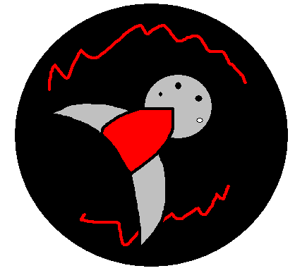
Groupings: craft 1, craft 2, storytime, games, snack

New categories!
craft 1 – bears, hats
craft 2 – kaleidoscope, constellations
story/games – raven, games
messages/rockets – language, rocket messages, rosetta stone, balloon messages
snack – flags, edible asteroids=astronaut food

Name Camp Name Size
Sweatshirts- Amanda- Pixie XS
Tracey- Noel Medium
Connie- Gold Large
Liz……
Tshirts- not fitted, normal shirts, light blue
- “you’re never too old to be a girl scout”
- “peace out girl scout” → Ilana design
Patch design…
The red squiggles are writing saying things like “Campus Girl Scouts Girl Fun Day 2007” and “To the Moon!”

