(Name goes here)  (Details go here)  &  UNITE FOR SIGHT  University of Washington Chapter  Vision Screening  (Date Goes Here)  (Time Goes Here)  (Location Goes Here) | 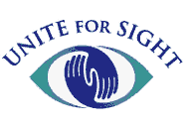

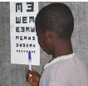 | Free Services Offered:  1. Connections to doctors that provide free eye care and glasses!  2. Eye care education!  - Age-Related Macular Degeneration  - Cataracts  - Diabetic Retinopathy  - Glaucoma  3. Vision screening!
Join us!

