_______Meeting Minutes:

Monday, February 4th, 2002

Quorum | 1 / 2 | 3 / 4 | 5 / 6 | 7 | 8
North | 3 | 1 | 2 | 0 | 1
South | 0 | 1 | 3 | 0 | 1

I. Proposals
- Operation Husky Stadium (Sarah):
  - $800
    - Passed
- 1 / 2 South Ski Trip (Devra):
  - $60
    - Passed
- Safe House Game Night (Sean):
  - $40, for food
    - Passed
- EMP & Space Needle Tour (Devon):
  - $80, for ticket costs
    - Passed
- Thoughts on a Higher Power (Devon):
  - $40, for food and refreshments
    - Passed
- Actual Budget: $3212.53
II. Reports
- ASUW (Sean):
  - RHSA Caucus Passed
  - E-Mail usage concerns relating to “Affordable Tuition E-mails”
- Rick’s Café (Alicia):
  - N/A
- RHSA:
- ResRights (Nick):
  - N/A
- CPC (Jacob):
  - All Capital Projects Passed this Year
- CAC (Jeannine):
  - Fill out Husky Den Survey
- CBR (Cara):
  - N/A
- Advisor (Sarah):
  - N/A

Announcements
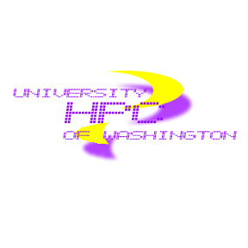
- Winterfest Organization Meeting: Feb. 5th in Grey Lounge @ 5:30pm

