Little Miss First Nations at UW 2014-2015 Royalty Guidelines and Contract

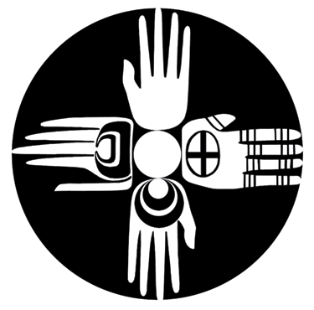

Each year First Nations at the University of Washington sponsors a royalty contest. In order to hold the title of Little Miss First Nations, the following guidelines must be upheld.

- Must be 5-12 years of age.
- Must have knowledge of her regalia and be fully dressed during the powwow.
- Must be of good moral character and have high personal standards. Appropriate conduct is expected and mandatory throughout her reign.
- Required to sell raffle tickets.
- Expected to attend at least eight powwows during her reign where she will be punctual for grand entries and dressed in full regalia with the crown and shawl.
- Required to keep in contact with First Nations and notify them of any circumstances that would interfere with her reign.
- Hold only the Little Miss First Nations title throughout her reign. If a contestant is found to be holding a crown for another powwow she will be disqualified from the competition. If she gives up her title, her crown will be returned immediately to the First Nations committee.

Little Miss First Nations at UW 2014-2015

Royalty Application

Applicant Information
Full Name: |  |  |  | Date:

Address:
 | Street Address | Apartment/Unit #

 | City | State | ZIP Code

Phone: |  | Email

Date of Birth:
Name of School Attending:
Year in School:

Family Background
Tribal Affiliation:

Parents:

Grandparents:

Siblings:

Please attach a resume that includes the following information:
- Why you want to be First Nations royalty
- How you will represent First Nations
- Qualifications (extracurricular activities, leadership opportunities, hobbies, special interests, previous royalty experience if applicable, etc.)
- GPA/Grades
Please attach an essay with one of the following questions. Please answer in essay format. Your essay must be 1-2 pages typed in 12 pt. font or 2-3 pages handwritten and legible.
- Why do you feel higher education is important within the Native American community and within the greater population?
- Describe in detail one person who has been an influencing factor toward your quest for knowledge of your traditional/tribal culture, and why that is important.
- Discuss the ways in which you participate in your cultural traditions and why it is important to you.

Signature
I, _________________________________________________, understand that if I am crowned Little Miss First Nations, I must comply with the guidelines as states above. If, for any reason, the First Nations committee feels that I have not represented their organization appropriately or have not conducted myself in accordance with their guidelines, the committee may forfeit my title as Little Miss First Nations. I understand that if my title is taken away, I will immediately return my crown to the First Nations committee.
Signature of Contestant: |  | Date:

Signature of Parent/Guardian: |  | Date:

